2.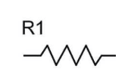 6.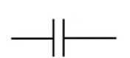 3.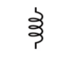 12.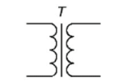
 |  |  | ¹ |  |  |  |  |  |  |  |  |  | ⁶
 |  |  |  |  |  |  |  |  | ⁵
 |  |  |  |  |  |  |  |  |  |  |  |  | ⁸
 |  | ² |  |  |  |  |  |  |  |  | ¹⁰
 |  | ³
⁴ |  |  |  |  |  |  | ¹¹
 |  |  |  | ⁹
⁷
 |  |  |  |  |  |  | ¹²

8.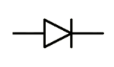 10. 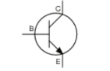 1. 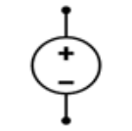 5. 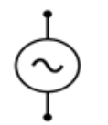

9.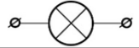 11. 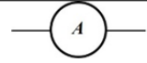 7. 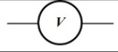 4.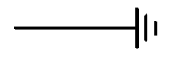

Javoblari:

1. ozgarmastok  2. rezistor  3. induktivgaltak  4. yergaulash  7. voltmetr  8. diod  12. transformator | 5. ozgaruvchantok  6. kondensator  9. lampa  10. tranzistor  11. ampermetr

