CYCLE SPORT
Cycle sport is competitive physical activity using bicycles. There are several categories of bicycle racing including road bicycle racing, cyclo-cross, mountain bike racing, track cycling, BMX, and cycle speedway. Non-racing cycling sports include artistic cycling, cycle polo, freestyle BMX, mountain bike trials and cycleball. The Union Cycliste Internationale (UCI) is the world governing body for cycling and international competitive cycling events. The International Human Powered Vehicle Association is the governing body for human-powered vehicles that imposes far fewer restrictions on their design than does the UCI. The UltraMarathon Cycling Association is the governing body for many ultra-distance cycling races.
Bicycle racing is recognised as an Olympic sport. Bicycle races are popular all over the world, especially in Europe. The countries most devoted to bicycle racing include Belgium, Denmark, France, Germany, Italy, the Netherlands, Spain and Switzerland.[1] Other countries with international standing include Australia, Luxembourg, United Kingdom, United States and Colombia.
The first bicycle race is popularly held to have been a 1,200 m (3,900 ft) race on the 31 May 1868 at the Parc de Saint-Cloud, Paris, France.[2] It was won by expatriate Englishman James Moore who rode a wooden bicycle with solid rubber tires.[3] The machine is now on display at the museum in Ely, Cambridgeshire, England.
The Union Cycliste Internationale was founded on 14 April 1900 by Belgium, the United States, France, Italy, and Switzerland to replace the International Cycling Association, which had been formed in 1892, over a row with Great Britain as well as because of other issues.
Since the rise of the Olympic Movement at the 1896 Summer Olympics, cycling has been a contestant event in every Summer Olympic Games.
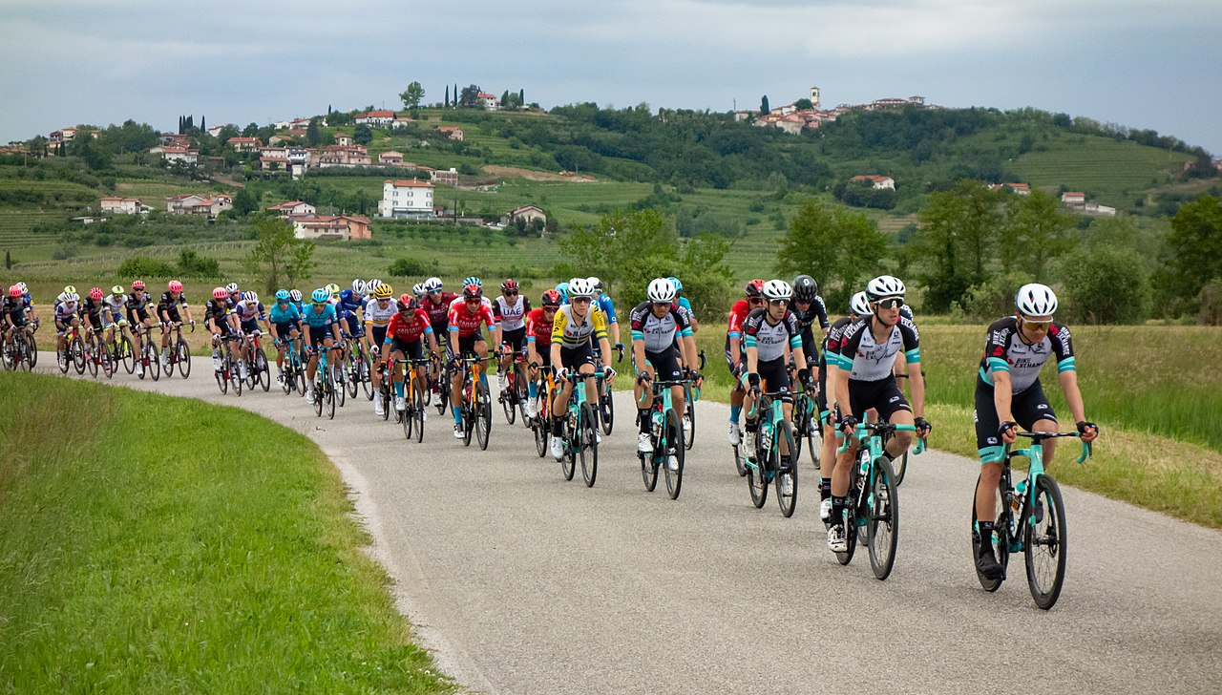

VELOSIPED SPORTI
Velosiped poygasining bir nechta toifalari mavjud, jumladan, yo'lda velosiped poygasi , siklo-kross , tog 'velosiped poygasi , trek velosport , BMX va velosiped tezligi . Poygadan tashqari velosport turlariga badiiy velosport , velopolo , erkin BMX , tog 'velosipedi sinovlari va velosipedbol kiradi . Velosipedchilar ittifoqi _ Internationale (UCI) velosiped sporti va xalqaro musobaqalar bo'yicha jahon boshqaruv organi hisoblanadi.
Velosiped poygasi Olimpiya sport turi sifatida tan olingan . Velosiped poygalari butun dunyoda, ayniqsa Yevropada mashhur. Velosiped poygalariga eng ko'p bag'ishlangan mamlakatlar qatoriga Belgiya, Daniya, Frantsiya, Germaniya, Italiya, Niderlandiya, Ispaniya va Shveytsariya kiradi. Xalqaro mavqega ega boʻlgan boshqa davlatlar qatoriga Avstraliya, Lyuksemburg, Buyuk Britaniya, Qoʻshma Shtatlar va Kolumbiya kiradi.
Saint- Cloud , Parij , Frantsiyada 1200 m (3900 fut) poyga bo'lib o'tdi . Mustahkam rezina shinalar bilan yog'och velosiped mingan chet ellik ingliz Jeyms Mur g'alaba qozondi .
Xalqaro velosipedchilar ittifoqi 1900 - yil 14-aprelda Belgiya, AQSh, Fransiya, Italiya va Shveytsariya tomonidan 1892-yilda Buyuk Britaniya bilan kelishmovchilik va boshqa muammolar tufayli tashkil etilgan Xalqaro velosipedchilar assotsiatsiyasi oʻrniga tashkil etilgan. .
1896 yilgi Yozgi Olimpiya o'yinlarida Olimpiya harakati kuchayganidan beri velosiped har bir yozgi Olimpiya o'yinlarida ishtirok etuvchi voqea bo'ldi .
