TASHKENT

Capital of Uzbekistan
Tashkent is the capital of and the most cosmopolitan city in Uzbekistan. It was noted for its tree-lined streets, numerous fountains, and pleasant parks, at least until the tree-cutting campaigns initiated in 2009 by the local government.
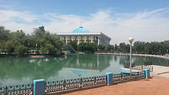

Alisher Navoiy Park
Since 1991, the city has changed economically, culturally, and architecturally. New development has superseded or replaced icons of the Soviet era. The largest statue ever erected for Lenin was replaced with a globe, featuring a geographic map of Uzbekistan. Buildings from the Soviet era have been replaced with new modern buildings. The "Downtown Tashkent" district includes the 22-story NBU Bank building, an Intercontinental Hotel, the International Business Center, and the Plaza Building.
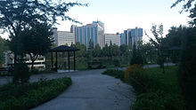

Japanese Gardens in Tashkent
The Tashkent Business district is a special district, established for the development of small, medium and large businesses in Uzbekistan.
In 2007, Tashkent was named a "cultural capital of the Islamic world" by Moscow News, as the city has numerous historic mosques and significant Islamic sites, including the Islamic University. Tashkent holds the Samarkand Kufic Quran, one of the earliest written copies of the Quran, which has been located in the city since 1924.

A first demonstration of fully electronic TV set to public and committee was made in Tashkent in summer 1928 by Boris Grabovsky and his team. In his method that had been patented in Saratov in 1925, Boris Grabovsky proposed a new principle of TV imaging based on the vertical and horizontal electron beam sweeping under high voltage. Nowadays this principle of the TV imaging is used practically in all modern cathode-ray tubes. Historian and ethnographer Boris Golender (Борис Голендер in Russian), in a video lecture, described this event.This date of demonstration of the fully electronic TV set is the earliest known so far. Despite this fact, most modern historians disputably consider Vladimir Zworykin andPhilo Farnsworth as inventors of the first fully electronic TV set. In 1964, the contribution made to the development of early television by Grabovsky was officially acknowledged by the Uzbek government and he was awarded the prestigious degree, 'Honorable Inventor of the Uzbek Soviet Socialist Republic'.

Geography and climate
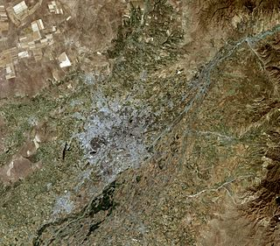
Tashkent41°18′N 69°16′E is situated in a well-watered plain to the west of the last Altai mountains citation needed]on the road betweenShymkent andSamarkand. Tashkent sits at the confluence of the Chirchik river and several of its tributaries and is built on deep alluvial deposits up to 15 metres (49 ft). The city is located in an active tectonic area suffering large numbers of tremors and some earthquakes. One earthquake in 1966 measured 7.5 on the Richter scale. The local time in Tashkent is UTC/GMT +5 hours.

Climate
Tashkent features a M erranean climate (Köppen: Csa) with strong continental climate influences (Köppen: Dsa). As a result, Tashkent experiences cold and often snowy winters not typically associated with most M erranean climates and long, hot and dry summers. Winters are cold and often snowy, covering the months of December, January and February. Most precipitation occurs during these months which frequently falls as snow. The city experiences two peaks of precipitation in the early winter and spring. The slightly unusual precipitation pattern is partially due to its 500 m (roughly 1600 feet) altitude. Summers are long in Tashkent, usually lasting from May to September. Tashkent can be extremely hot during the months of July and August. The city also sees very little precipitation during the summer, particularly from June through September.

Demographics
In 1983, the population of Tashkent amounted to 1,902,000 people living in a municipal area of 256 km2 (99 sq mi). By 1991, (break-up of Soviet Union) the number of permanent residents of the capital had grown to approximately 2,136,600. Tashkent was the fourth most populated city in the former USSR, after Moscow, Leningrad (St. Petersburg), and Kiev. Nowadays, Tashkent remains the fourth most populous city in the CIS and Baltic countries. The population of the city was 2,295,300 people in 2004.

As of 2008, the national structure of Tashkent was as follows:
63.0% - Uzbeks
20.0% - Russians
4.5% - Tatars
2.2% - Koryo-saram (Koreans)
2.1% - Tajiks
1.2% - Uighurs
7.0% - other ethnic backgrounds

Districts
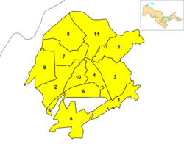

City districts of Tashkent
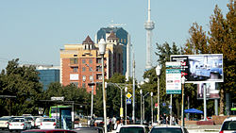

Streets of Tashkent
Tashkent is currently divided into the following districts (Uzbek: 'Tuman'):
At the time of the Tsarist take over it had four districts (Uzbek daha):
Beshyoghoch
Kukcha
Shaykhontokhur
Sebzor
In 1940 it had the following districts (Russian район):
Oktyabr
Kirov
Stalin
Frunze
Lenin
Kuybishev
By 1981 they were reorganized into:
Bektemir
Akmal-Ikramov (Uchtepa)
Khamza (Hamza)
Lenin (Mirobod)
Kuybishev (Mirzo Ulugbek)
Sergeli
Oktober (Shaykhontokhur)
Sobir Rakhimov (Olmazar)
Chilanzar
Frunze (Yakkasaray)
Kirov (Yunusabad)

