TRAVELLING
There is nothing quite like traveling, like seeing a new place for the first time or returning to a favorite place. People of all ages, from all countries, travel to foreign places for many different reasons – namely work, family and leisure. Whether by plane, train, ship or automobile, travel is generally a pleasurable experience, at least for the people who can financially afford comfortable and safe methods of travel. But it has more benefits than satisfying one’s need to make money, as well as to see loved ones and enjoy one’s self on vacation. There are other benefits of traveling that many people often overlook.

HOW DIETING AND EXERCISING CAN CHANGE YOUR LIFE?

One of the traveling benefits is finding and keeping humility. Too often, people get wrapped up in their lives, their daily routine of working, sleeping, eating and living. They become self-absorbed to the point it affects their health, their happiness, and their perspective.
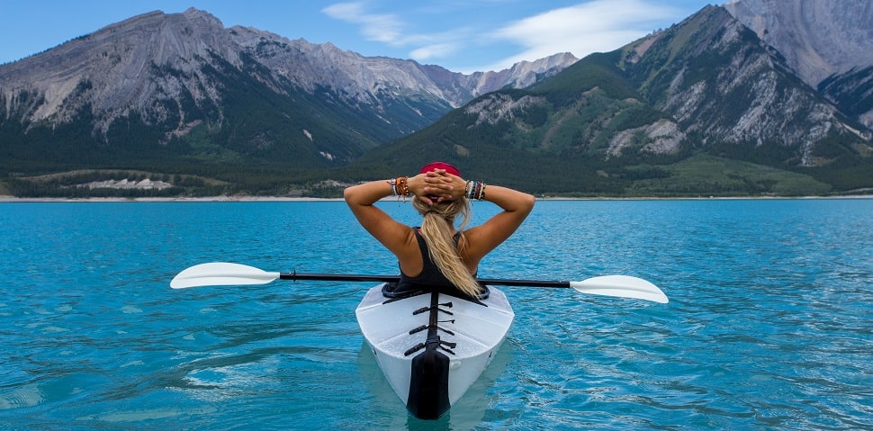
It’s a great, big world out there with billions and billions of people, who each day live their life and have their own unique experiences.
Travel reminds those paying attention that they are not the only ship in the sea, that this is a huge world and that they are only a small, insignificant pea in it. This is quite a humbling experience – to go to another country and see large numbers of peoples living differently, and coming to understand how large the crazy world actually is. When people who learn return home, they keep with them this perspective for the rest of their life and they benefit from this is knowledge and perspective.
Another benefit to traveling is coming to see one’s native country in a different light, in a different way. This is done through being able to compare and contrast home from a foreign location, done most always through traveling. A new perspective may be formed.
Away from home, one comes to understand what “home” actually is and what it means.
Perhaps their native country is not as free as they had been told or originally thought it to be, for example. One does not understand what it means to be a citizen of their native country until they have seen it from a distance, from another, completely different country. When traveling elsewhere and having to live according to a foreign place’s laws and social norms, one immediately thinks of how things are done in their own country and culture and begins to favor one way or another. This changes how one feels about their native country, whether in a better or worse light. This notion can be applied to various characteristics, such women’s rights, human rights, customs and traditions, beliefs, a trust of government, etc. Traveling is always beneficial for the individual experiencing it.
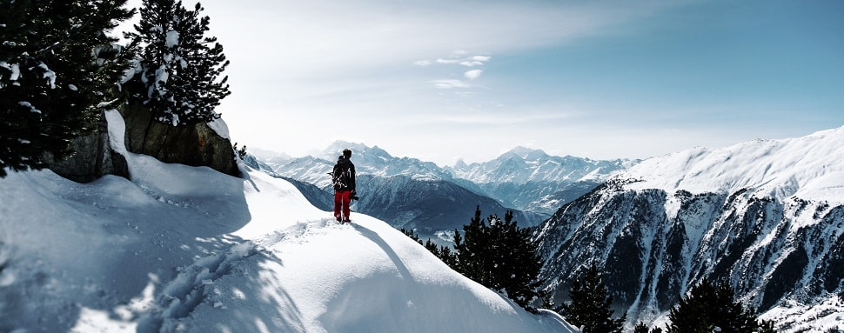
Another great benefit to traveling is the life experience. Many people in the world do not have the luxury of going to another country for pleasure, or even to another city in their native country for that matter.
Traveling gets a person out of their comfort zone, away from all their normal pleasures and comforts and way of doing things.
This forces them to be adventurous, to live life to the fullest, to take the most of this precious gift of life and use the time they have to discover new things, meet new people and experience a completely different life – much like people experience when reading fictional stories: They get to become whoever they are reading about, just like in travel they get to become the citizens of the country they are visiting, even if for just a short time. They live outside themselves.
To conclude, traveling is good for a person of any age. It not only helps people to form a better understanding of themselves, their beliefs and their lives, it also provides people with a better understanding of the world in which they live, even if it’s beyond their immediate environment. And it may even help a person to feel connected to the many people living in the world, even if their lives never meet, even if their lives are so completely different that they may as well be from different planets.
There are no hesitations. Go. Privatewriting.com will take care of your academic success. Just place an order and get ready for the trip.

I love the logistics of traveling
I like landing in a new place and trying to figure it all out myself. Where to get money. How to speak the language. How to go from point A to point B. How to pack my bag right so I don’t go insane after packing it for the 135thtime. Well, okay, maybe I don’t love that mundane task, but I still figure it’s better than all the tedious chores I left back home when I decided to travel. It all actually becomes easier and easier as it goes and gives you the sense of confidence that you can do anything. If I can plop down in an airport amidst the chaos of Cairo or hubbub in Hanoi and manage to get myself into the heart of town and find a place to stay, all the while, not getting ripped off and keep my sense of humor, then I am certainly not really worried about being able to go anywhere, anytime.

I love the simplicity of it all.
My only job is to go somewhere and figure out how to do it. My to-do list is rather short: figure out the exchange rate and get cash out of an ATM, figure out a few key words in the native language, figure out transport to my lodging and around town, exchange books (find English used bookstore), do laundry every 2 weeks or so. Because I travel for longer periods, occasionally I also have to: get a haircut and buy new clothes to replace ratty, holey old ones.
Everything you own is with you in one bag. You only have a few pairs of pants or t-shirts, so getting dressed each day is an easy task. The more we have, the more it seems to weigh us down. Your life isn’t complicated by all the nonsense that is back home. But, guess what? If you really need a new shirt or shoes… you can buy it anywhere in the world. There is not much we actually really need and I think in this mega-consumerist society, we too often forget that. You need food and you need shelter… that’s about it. I enjoy some love, laughter, and happiness too… but that’s free and takes up no space in my luggage.

I love meeting new people all the time.
In no other time in my life have I met so many people and made so many new friends in such a short time. The world is full of friendly, generous people. Sure, every place has its share of nitwits too, but as a traveler, you seem much less likely to meet them. Maybe because people want to help you or maybe because you just don’t know some people long enough to uncover their schmuck-like tendencies. Since the nature of travel is to keep moving, these folks never become boring… because you simply don’t know them long enough to discover their flaws or get sick of them.

I love the freedom.
I experience a great feeling of independence from traveling solo. I can go wherever I want, whenever I want. I can sleep in. I can stay out late. It’s all up to me.
Traveling around the world for the last few years has brought incredible experiences. Everyone enjoys traveling because there is no right way to travel. There are newbie’s and those afraid of adventure that travel with fanny packs and extra security features. There are the adventurous that leave everything to the unknown. There are travelers right in between, young and old, experienced and not experienced.

We live in a society of customs and expectations. A society that expects us to do certain things. We all start to attend school and those that don’t finish are not held in high regard in our society.

Most of us start university and are expected to get good grades and eventually find a job.

