14.02.2024 Davronbek Yo’ldoshev 304-guruh
Sezer shifri kodi
shifr = input("So'z kirit: ")
kalit = int(input("a= "))
qiymat = ""
for i in shifr:
qiymat += chr(ord(i) + kalit)
print(qiymat)
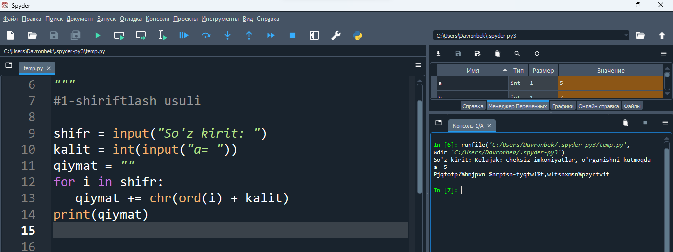
Sezer dishifri kodi
shifr = input("Shifrlangan so'z kirit: ")
kalit = int(input("a= "))
qiymat = ""
for i in shifr:
qiymat += chr(ord(i) - kalit)
print(qiymat)
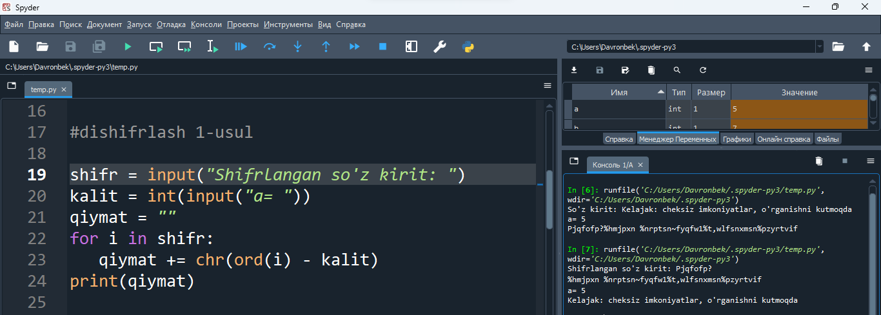
Affinsezar shifr va dishifrlash kodi
def affine_encrypt(matn, a, b):
shifrlangan_matn = ""
for harf in matn:
if harf.isalpha():
if harf.isupper():
# Katta harflarni shifrlash
shifrlangan_matn += chr((a * (ord(harf) - ord('A')) + b) % 26 + ord('A'))
else:
# Kichik harflarni shifrlash
shifrlangan_matn += chr((a * (ord(harf) - ord('a')) + b) % 26 + ord('a'))
else:
# Alifbo xarflari emas bo'lgan belgilarni o'zgarmas qoldirish
shifrlangan_matn += harf
return shifrlangan_matn

#################################################

def affine_decrypt(shifrlangan_matn, a, b):
matn = ""
a_inverse = 0
for i in range(26):
if (a * i) % 26 == 1:
a_inverse = i
break
for harf in shifrlangan_matn:
if harf.isalpha():
if harf.isupper():
# Katta harflarni de-shifrlash
matn += chr((a_inverse * (ord(harf) - ord('A') - b + 26)) % 26 + ord('A'))
else:
# Kichik harflarni de-shifrlash
matn += chr((a_inverse * (ord(harf) - ord('a') - b + 26)) % 26 + ord('a'))
else:
# Alifbo xarflari emas bo'lgan belgilarni o'zgarmas qoldirish
matn += harf
return matn
# Test qilish
matn = input("So'z kirit: ")
a = int(input("a= "))
b = int(input("b= "))
shifrlangan_matn = affine_encrypt(matn, a, b)
de_shifrlangan_matn = affine_decrypt(shifrlangan_matn, a, b)
print("Matn: ", matn)
print("Shifrlangan matn: ", shifrlangan_matn)
print("De-shifrlangan matn: ", de_shifrlangan_matn)
